**CUSTOMER DATA MANAGEMENT SYSTEM**

**PROJECT REPORT**

**18CSC202J/ 18AIC203J - OBJECT ORIENTED DESIGN AND PROGRAMMING LABORATORY**

**(2018 Regulation)**

**II Year/ III Semester**

**Academic Year: 2022 -2023**

By

**SWETHA SURESH(RA2111026010259)**

**YUKTHAMUKHI RANGINENI (RA2111026010262)**

Under the guidance of

**Dr. M.UMA**

**Assistant Professor**

**Department of Computational Intelligence**



**FACULTY OF ENGINEERING AND TECHNOLOGY**

**SCHOOL OF COMPUTING**

**SRM INSTITUTE OF SCIENCE AND TECHNOLOGY**

**Kattankulathur, Kancheepuram**

**NOVEMBER 2022**

**PROBLEM DESCRIPTION**

The basic problem in managing the contact is Contact Selection, Data Entry, Tool Diversity .However, contact management has a number of associated difficulties. At first glance, the main problem informants had was the number of contacts they needed to manage. We estimate that this number varied from a low of several hundred to well into the thousands, although reliable estimation was hard given the large number of contact management tools people typically used, and the fact that there was often duplication between these. Upon further examination, though, deeper problems concerned:

(a) the need to make an explicit decision that someone was a valuable contact.

(b) the diversity of tools used.

(c) data entry

**Suggested Software Tools for UML**

StarUML, Rational Suite, Argo UML (or) equivalent, Eclipse IDE and J unit

## CLASS DIAGRAM

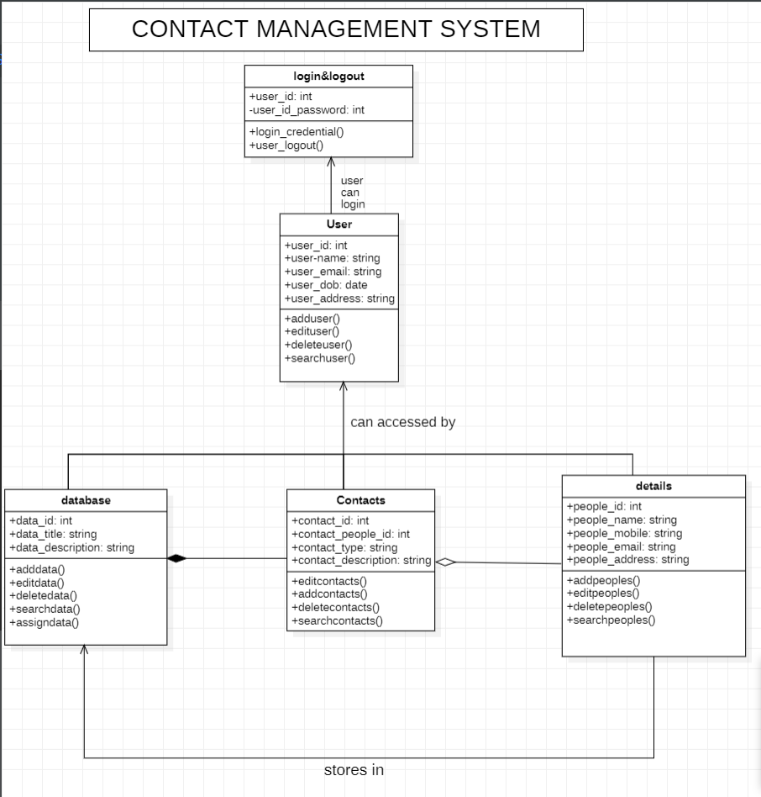

CLASSES OF CONTACT MANAGEMENT SYSTEM

* Login & logout: user can login and logout
* User: user can access data
* Data base: to store contacts and details
* Contacts: to add, edit, delete contacts
* Details: to store details about contacts

CLASSES AND ATTRIBUTES OF CONTACT MANAGEMENT SYSTEM

* **Login & logout**: user_id, user_id_password
* **User**: user_id,user_name,user_email,user_dob,user_address
* **Database**: data_id,data_title,data_description
* **Contacts**:contact_id,contact_type,contact_people,_id,contact_description
* **Details**:people_id,people_name,people_mobile,people_email,people_address

CLASSES AND METHODS OF CONTACT MANAGEMENT SYSTEM

* **Login&logout**: login_credential(),user_logout()
* **User**: add_user(),edit_user(),search_user(),delete_user()
* **Database**:add_data(),delete_data(),search_data(),assign_data(),edit_data()
* **Contact**:add_contact(),delete_contact(),search_contact(),edit_contact()
* **Details**:add_details(),delete_details,search_details(),edit_details

RELATIONSHIP OF CLASSDIAGRAMS

**Association**: database, contact, details are associated with each other and these can be accessed by the user who logs in.

**Aggregation**: even if one details is not there also, the contact still exists.

**Composition**: A database consists of multiple contacts, and if you delete the data base, all the contacts will be lost.

**Directed association**: users can only login and logout.

# USE CASE DIAGRAM

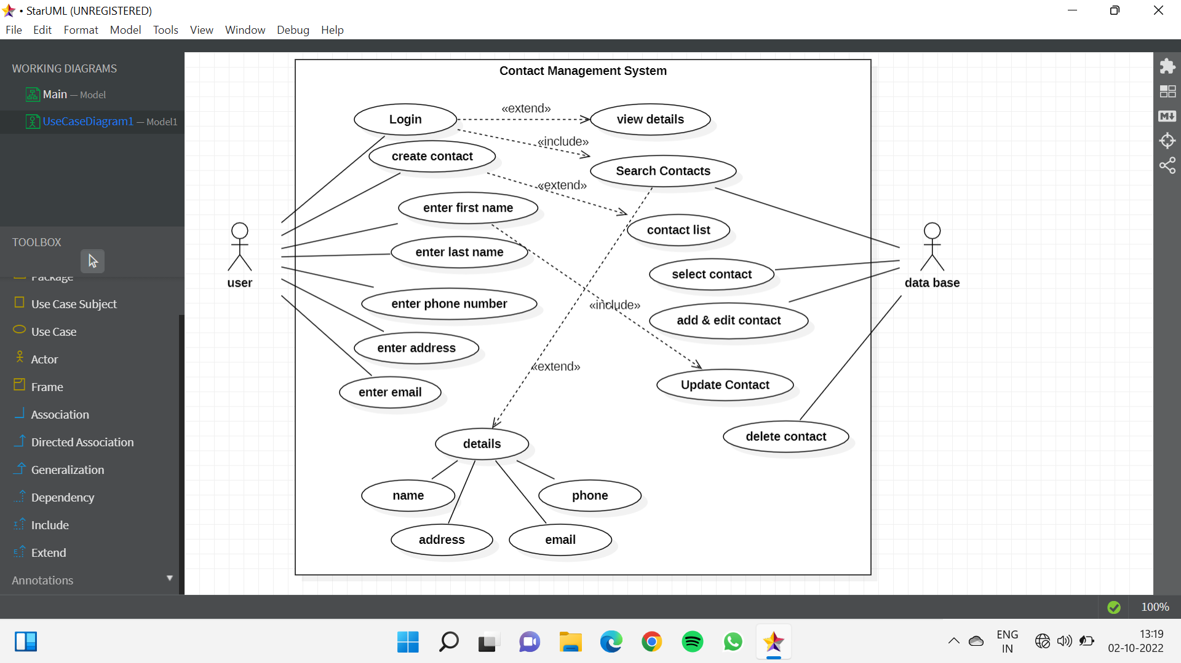

**ACTORS OF CONTACT MANAGEMENT SYSTEM**

* User: User can Access the Data.
* Data Base: To Store Contacts and Details.

**RELATIONSHIP OF CASES**

* Include Relationships: Login and Enter First name includes in search of contacts and updating the contact.
* Extend Relationships: Where Login, create contact and search contacts extend in viewing details, contact list and minute details like Name, Phone, Address and Email.

# SEQUENCE DIAGRAM

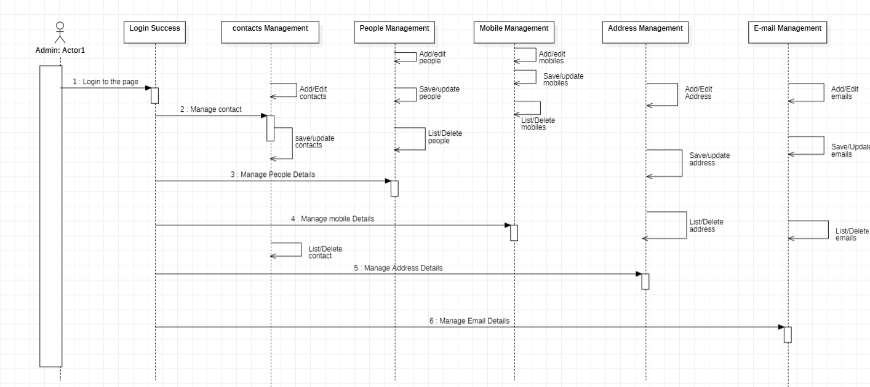

This is the UML sequence diagram of Contact Management System which shows the interaction between the objects of Peoples, Phone Numbers, Address, Contacts and Mobiles. The instance of class objects involved in this UML Sequence Diagram of Contact Management System are as follows:

* Peoples Object
* Phone Numbers Object
* Address Object
* Contacts Object
* Mobiles Object
* E-mail Object

# COLLABORATION DIAGRAM

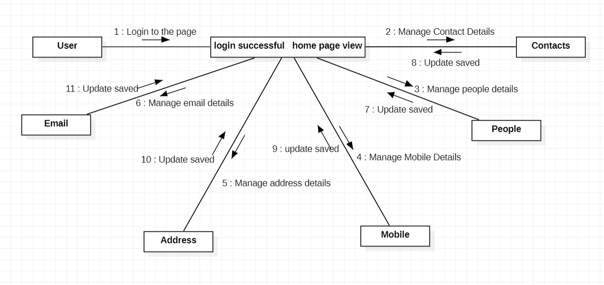

**Contact Management System entities and their attributes:**

* Contacts Entity: Attributes of Contacts are contact_id, contact_people_id, contact_type, contact_description
* Peoples Entity: Attributes of Peoples are people_id, people_name, people_mobile, people_email, people_username, people_password, people_address
* Mobiles Entity: Attributes of Mobiles are mobile_id, mobile_people_id, mobile_number, mobile_type, mobile_description
* Address Entity: Attributes of Address are address_id, address_people_id, address_place, address_type, address_description
* Email Entity: Attributes of Emails are Email_id, Email_people_id, Email_place,Email_type, Email_description
* Phone Numbers Entity: Attributes of Phone Numbers are phone_id, phone_people_id, phone_number, phone_type, phone_description

**Description of contact management system collaboration diagram:**

* The details of Contacts is store into the Contacts tables respective with all tables.
* Each entity (Phone Numbers, Mobiles, Email, Peoples, Contacts) contains primary key and unique keys.
* The entity Mobiles, Email has binded with Contacts, Peoples entities with foreign key.
* There is one-to-one and one-to-many relationships available between Email, Address, Phone Numbers, Contacts.
* All the entities Contacts, Email, Mobiles, Phone Numbers are normalized and reduce duplicacy of records.
* We have implemented indexing on each table of Contact Management System tables for fast query execution.

# STATE CHART DIAGRAM

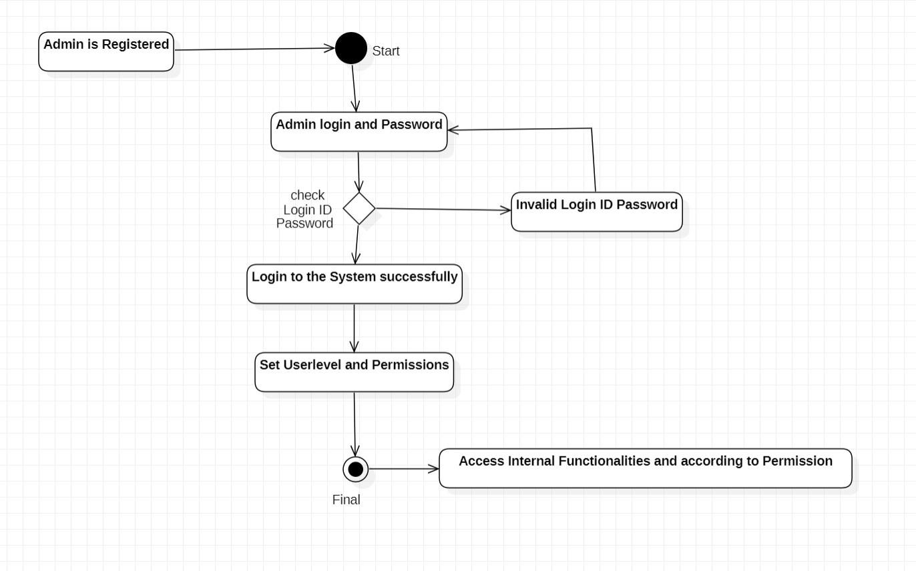

* This activity shows the flow of Login activity, where admin will be able to login using their username and password.
* After login user can manage all the operations on phone numbers, peoples, contacts, email, address.
* All pages such as contacts, email, phone numbers, peoples, contacts and address page.

# 

# ACTIVITY DIAGRAM

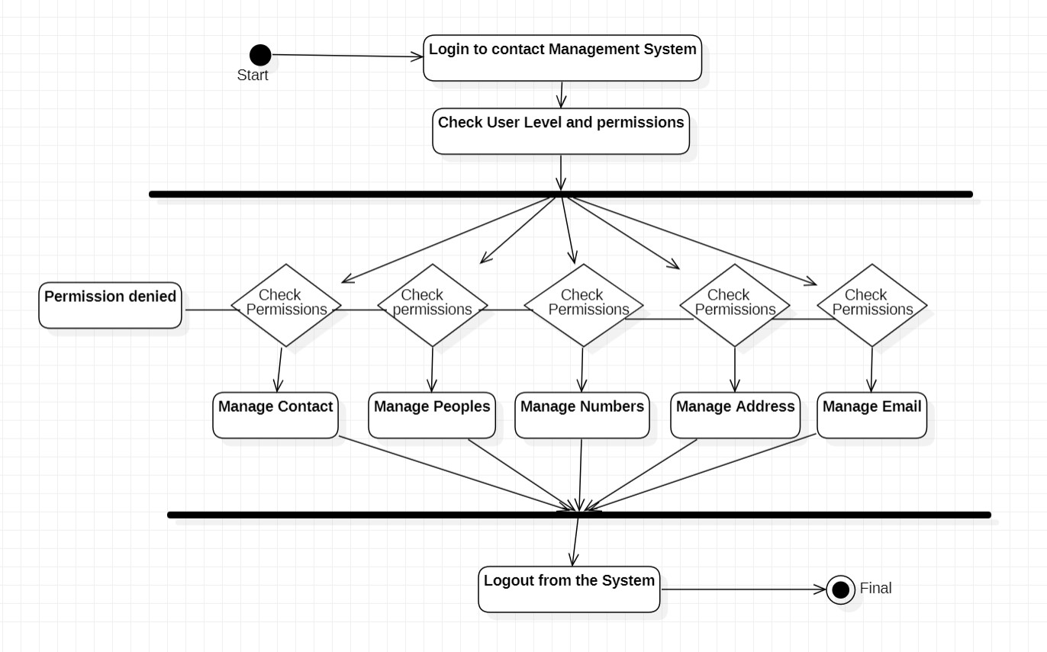

* This Activity shows the activity flow of editing, adding and updating of contacts.
* User will be able to search and generate report of phone numbers, Address, Emails. All objects are interlinked.
* Admin user can search peoples, view description of a selected people, add people, update people and delete people.
* Fork node will perform more than 2 or 3 operations, here we are performing 5 operations.
* These 5 operations are merged using join node.

# PACKAGE DIAGRAM

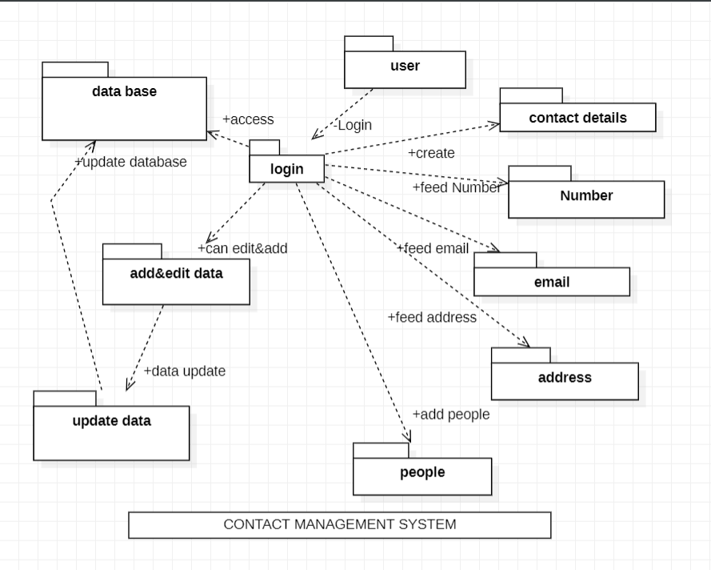

Package diagram:

* Package diagrams are used to structure high level system elements. Packages are used for organizing large system which contains diagrams, documents and other key deliverables.
* A package is a collection of logically related UML elements.
* Packages are depicted as file folders and can be used on any of the UML diagrams.
* Components of package diagrams are:
  + Contact details
  + Data base
  + User
  + Login
  + Add or edit data
  + Update data
  + People
  + Address
  + Email
  + Number

# COMPONENT DIAGRAM

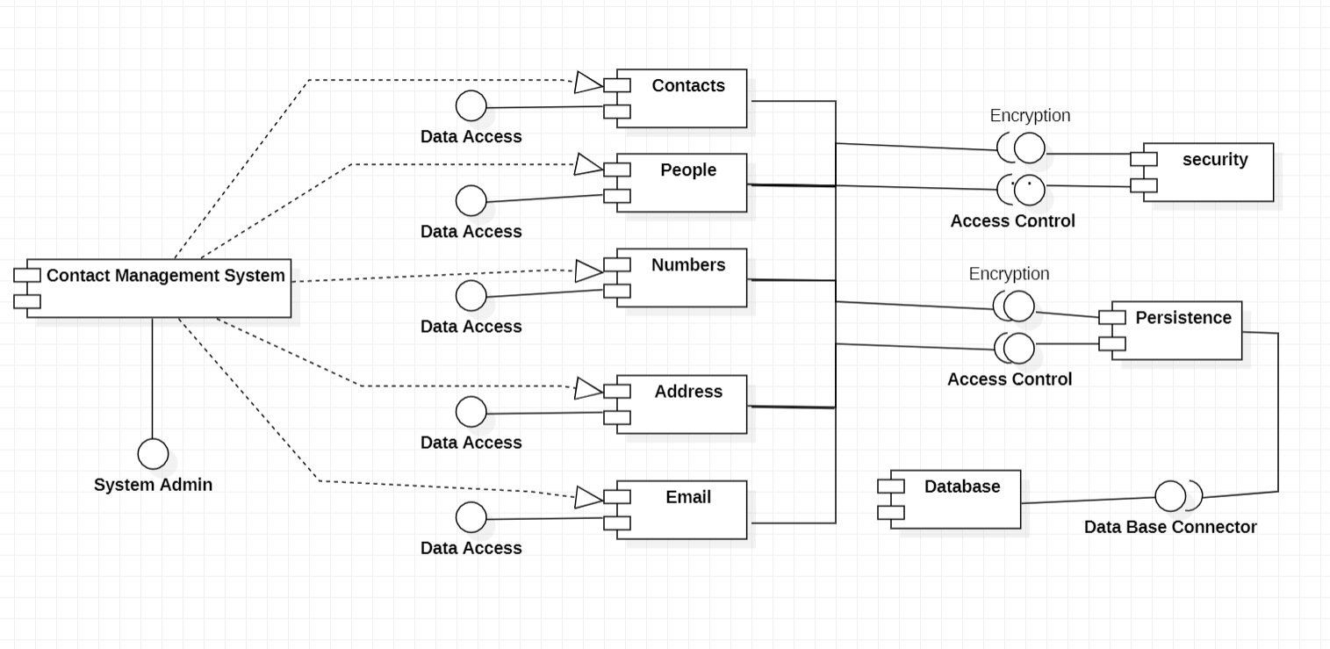

**Components of component diagram:**

* Contacts Component
* People Component
* Numbers Component
* Address Component
* Email Component

# DEPLOYMENT DIAGRAM

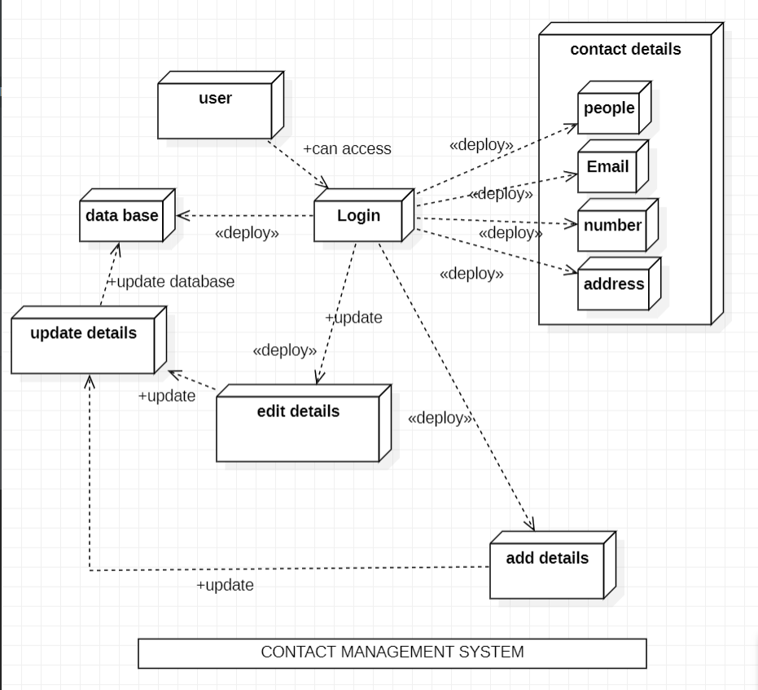

Deployment diagram:

* A deployment diagram consists of nodes which describe the physical devices used inside the system.
* On these nodes, artifacts are deployed. We can also have node instances on which artifact instances are going to be implemented.
* Node and artifacts of a system participate in the final execution of a system.
* Components of deployment diagram:
  + Contact details
  + Data base
  + User
  + Login
  + Add or edit data
  + Update data
  + People
  + Address
  + Email
  + Number

**CONCLUSION:**

Contact Management is a very basic and a daily used application. In our day-to-day life we save, delete, search contacts. To ease this process, we have made a personal Contact Management application which will make this casual process easier. Its all that you find all the details of the contact like name, phone number, Address, Email, etc. in just one contact…

**REFERENCES:**

* **https://www.freeprojectz.com/c-projects-projects/c-project-**
* **https://youtu.be/Ba7SyM78cUm**